Fantasy Cricket

Copyright © 2015-2016. All Rights Reserved.

No part of this document can be reproduced, transferred, distributed or stored in any format without the prior written permission of Authors.

User Manual

Contents

Chapter 1: Introduction 3

Fantasy Cricket Overview 3

About the User Manual 3

Address 3

Chapter 2: Get Started 4

Sign Up 4

Log In 5

View Latest Point 7

Schedule 8

Results 8

Rules and Scoring 9

Change Team 10

View Top Scorer 10

Statistics 11

Change Password 13

Sign Out 13

# Chapter 1: Introduction

## Fantasy Cricket Overview

**Fantasy Cricket** is a part of the Fantasy Sports genre. It is an online game where you create a virtual team of real cricket players and score points depending on how your chosen players perform in real life matches. To win a tournament, you must work towards attaining the maximum points and the No. 1 rank on the leader-board.

## About the User Manual

This user manual covers all features included in Fantasy Cricket Website.

## Address

www.fantasycricketbd.com

# Chapter 2: Get Started

## Sign Up

You must sign up to use this website’s full features. Sign up option will appear top right corner of the window, shown below. By clicking, you will enter to a new page where you can give necessary information and then register.

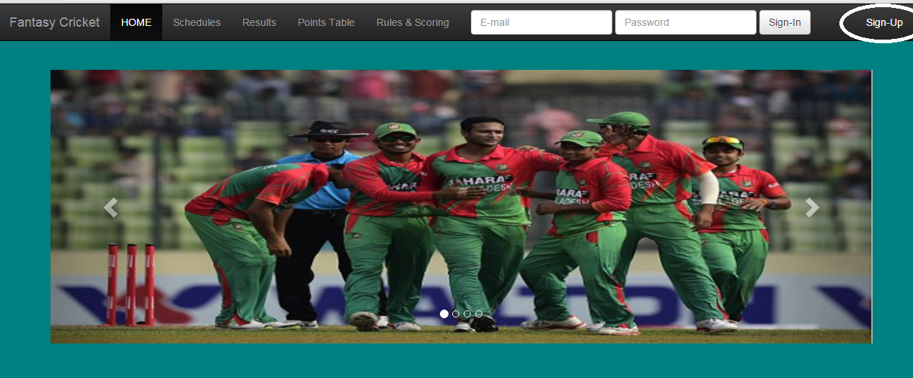

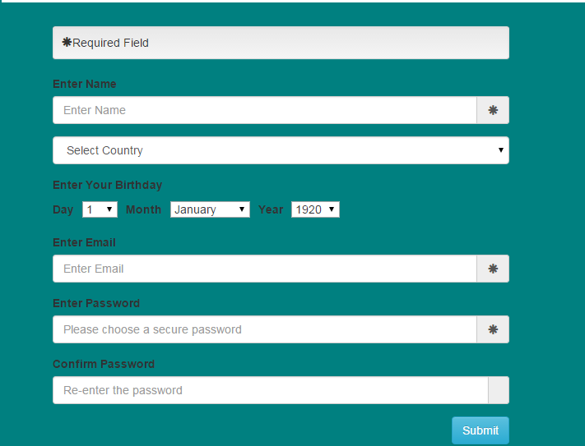

Required fields are specified by (*) mark. You must fill up the required fields to proceed further. By clicking submit you finish the registration process.

You can access some feature without having an account like Rules and Scoring, Schedule of the matches, Points Table of the teams, Results of the matches. You can also view the information of the developers in ‘About us’ section in the Home Page bottom-left corner.

## Log In

You must enter their respective your login email address and password to enter the website. If you are a new user (i.e) you have no team yet then a template of team creation page will be shown in the home page.

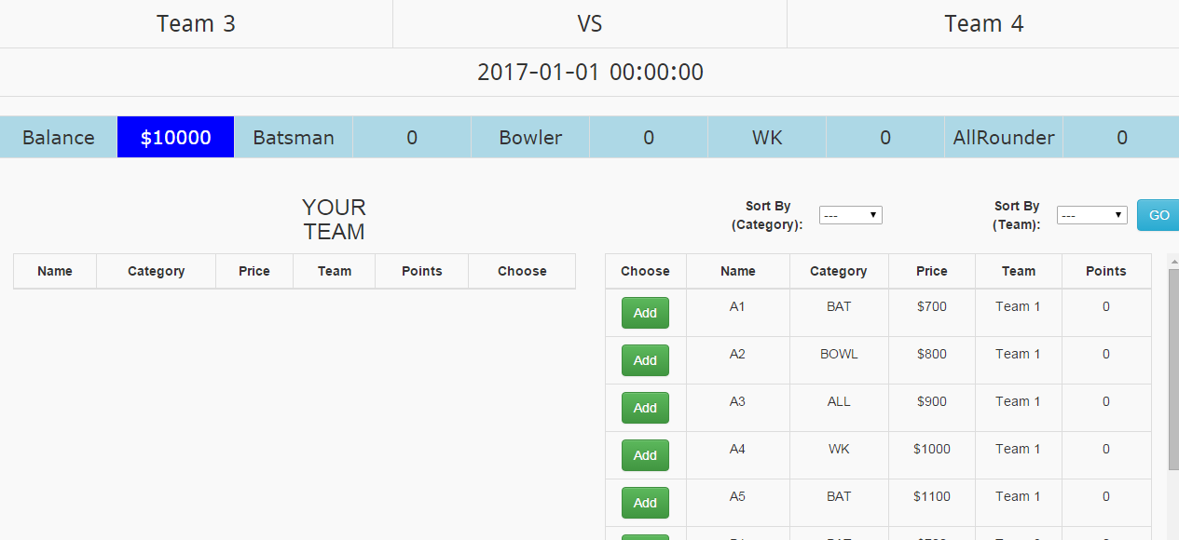

You will be given 10000$ virtual unit, shown in the Balance section. Available player list is shown in the right. According to your choice 11 players will be selected by clicking add button. Not every player will be available according to the rules. So, you must first learn the rules of selecting players from player pools. This information will be at rules and scoring section. You can sort the player list according to team or category. After selecting 11 players you must insert your team name and choose a captain for your team. Selected Captain will be given double points so this selection will vary user to user and upon this choice your points will differ.

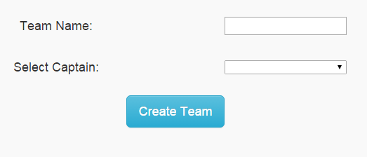

By clicking create team you will successfully create your team and continue.

If you have already a team then at the home page your team current configuration players will be shown.

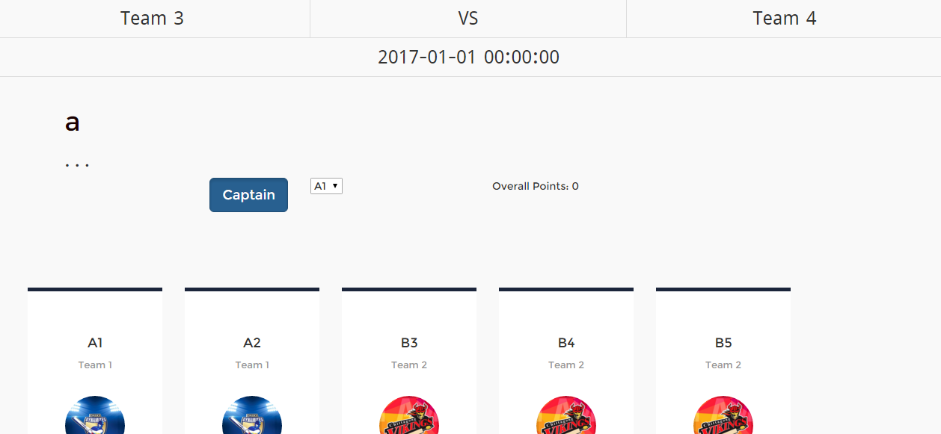

You can see the category of the selected players and earned points.  
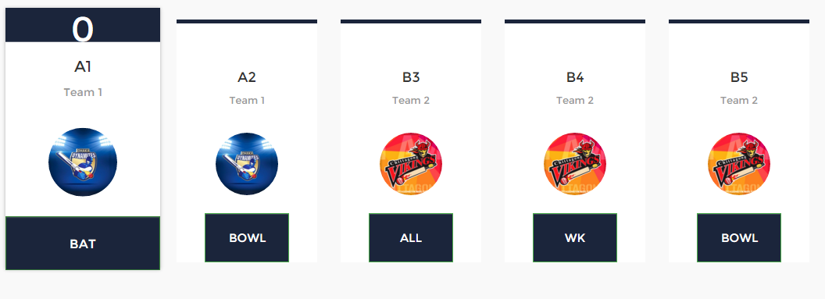

## View Latest Point

If you want to see your teams’ last match performance the data will be shown by clicking latest point section in the navigation bar.

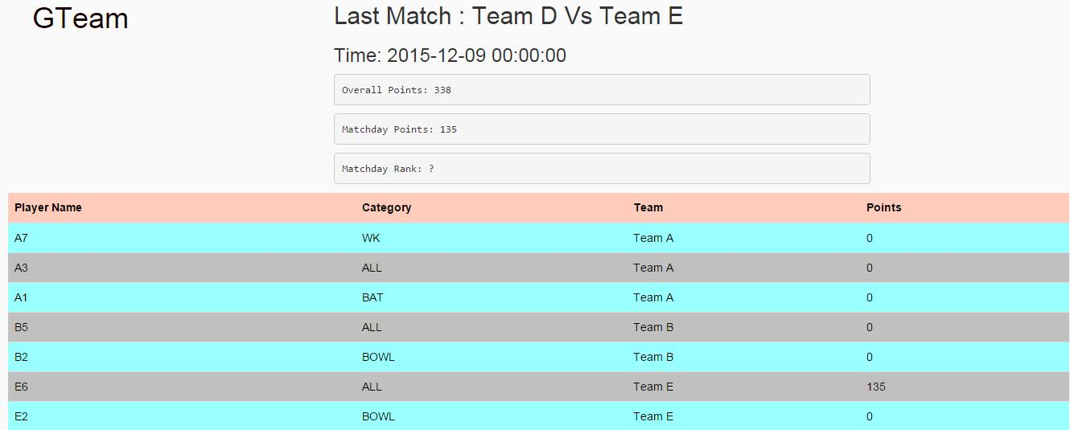

## Schedule

By clicking schedule tab you will see the upcoming matches in the tournament.

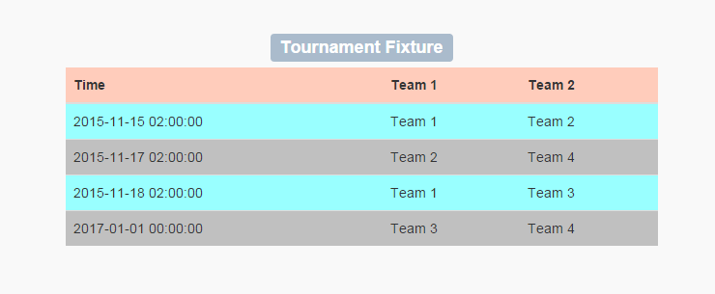

## Results

You will see the results of the previous matches after clicking results tab.

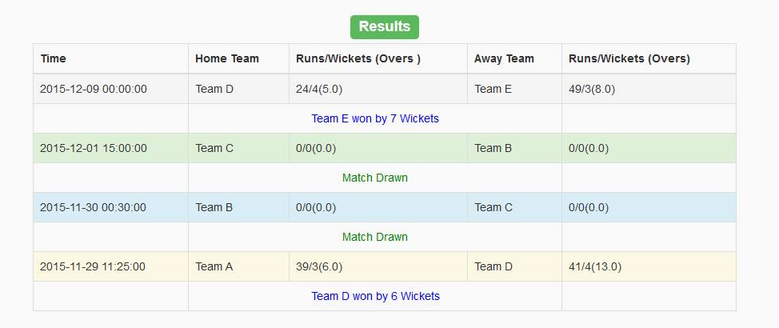

## 

## Rules and Scoring

You need to learn the rules and scoring system in order to familiarize yourself. There are two tabs in the window. ‘How to play’ and ‘Scoring System’.

In the How to play section team formation i.e. how many players from each category will be selected is given.  
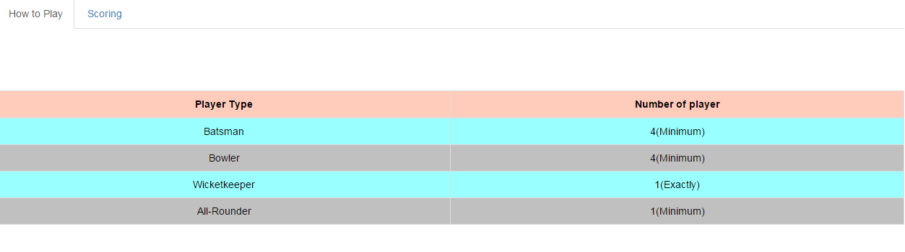

In the scroing section, points allocated for every possible section is given, according to the points specified your overall points will be calculated.

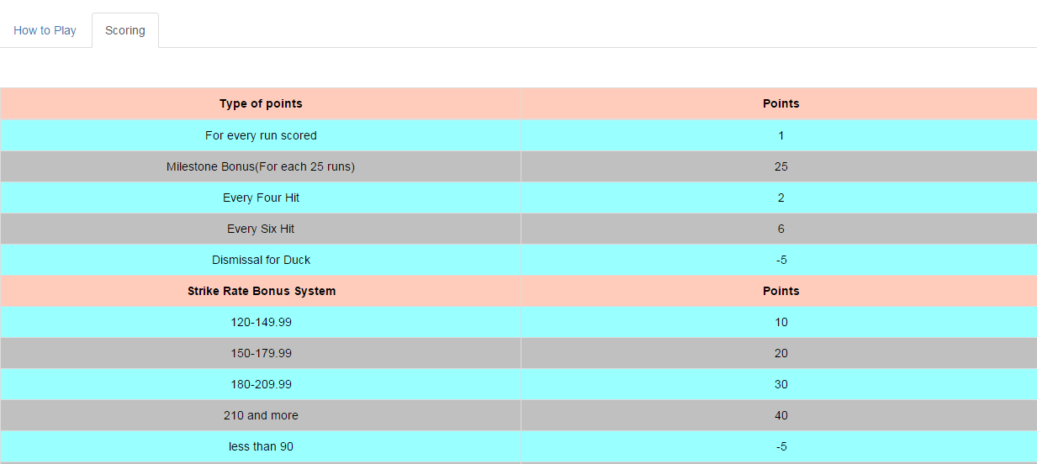

## Change Team

For every match you can modify your team by clicking to change team tab. According to the balance you can add or remove others or existing players to and from the list.

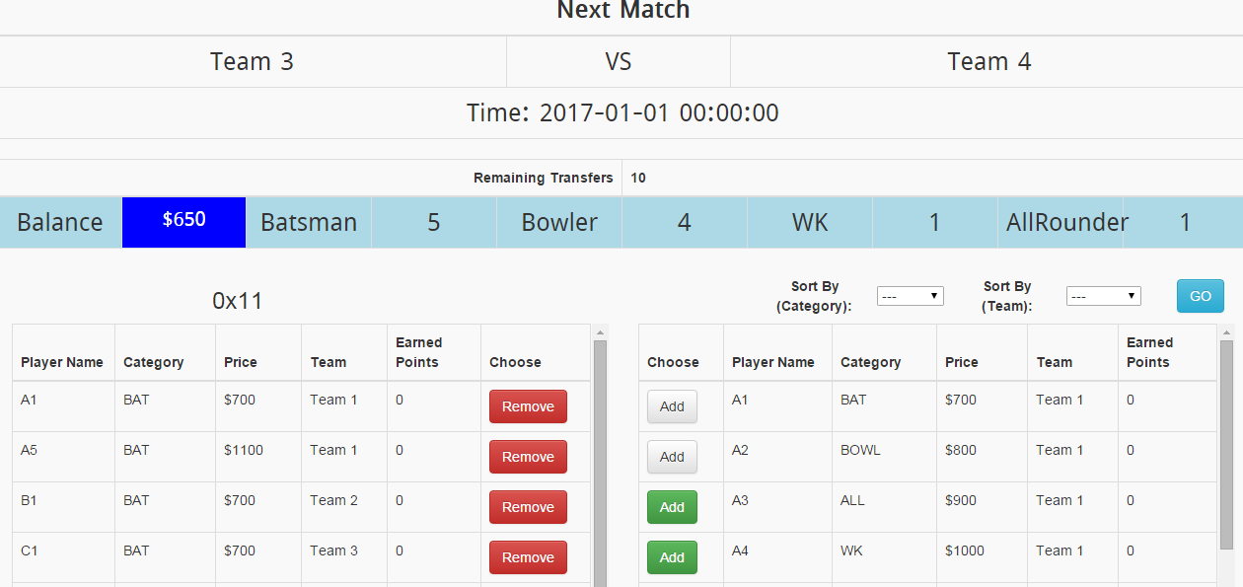

## View Top Scorer

There are two options in the top Scorer window. Top scoring players and top scoring users.

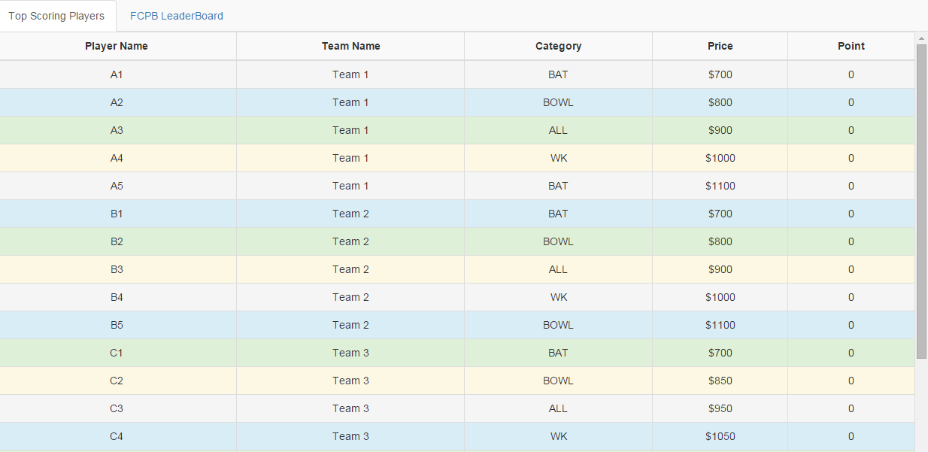

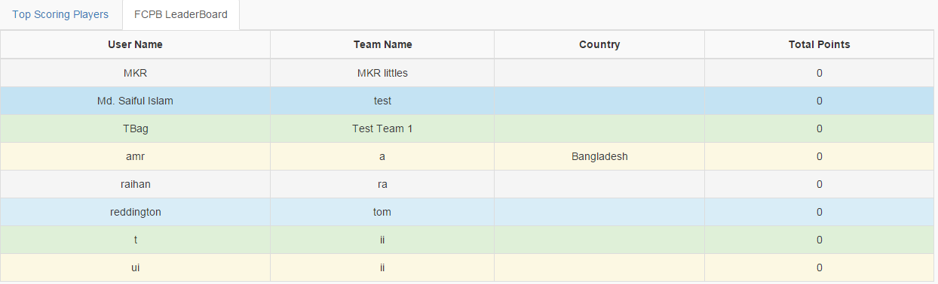

## Statistics

In this section overall contribution (categorywise and teamwise) are shown in column graph. If you wish to see then you need to click per category per team link, statistics > per category per team.

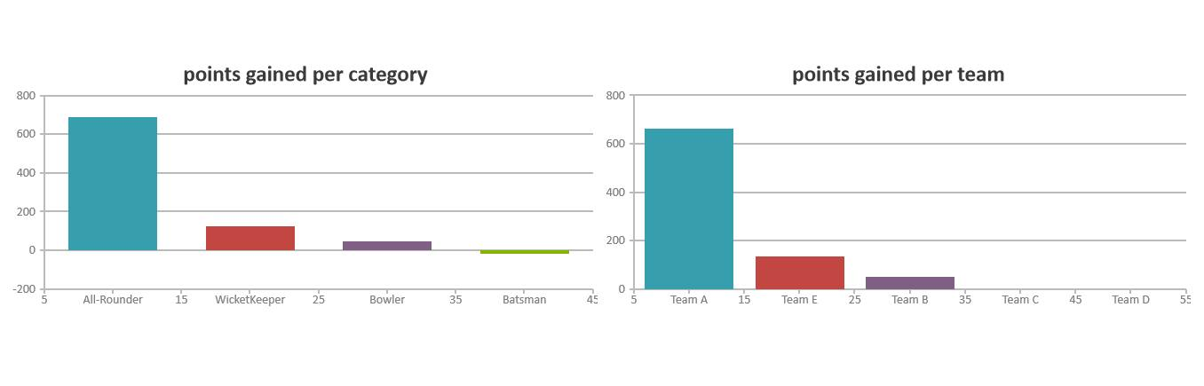

If you wish to see to per match data Statistics > Match by Match

If you wish to see to Player by Player Statistics > Player by Player

In the match by match or player by player page user needs to click in the rows to view the embedded data.

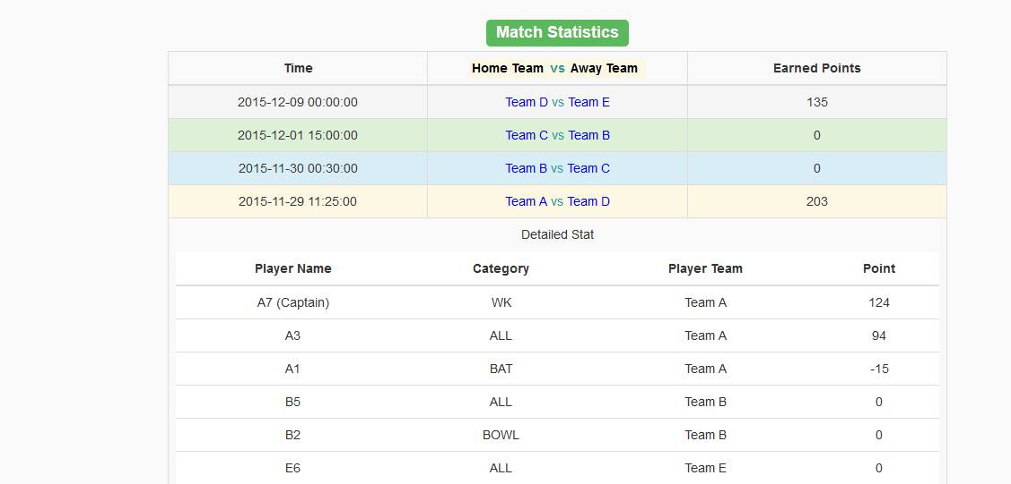

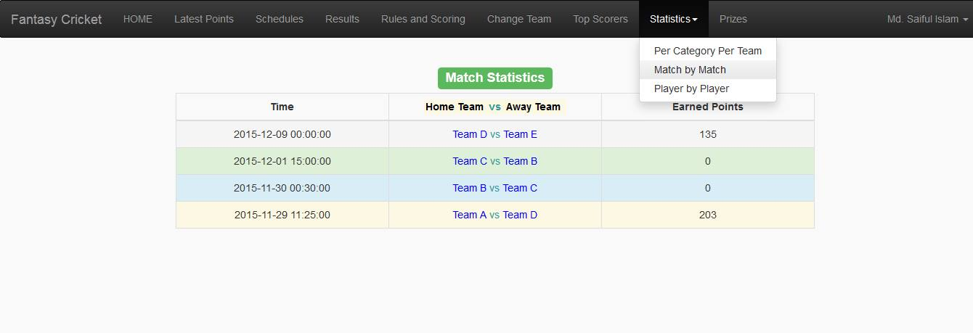

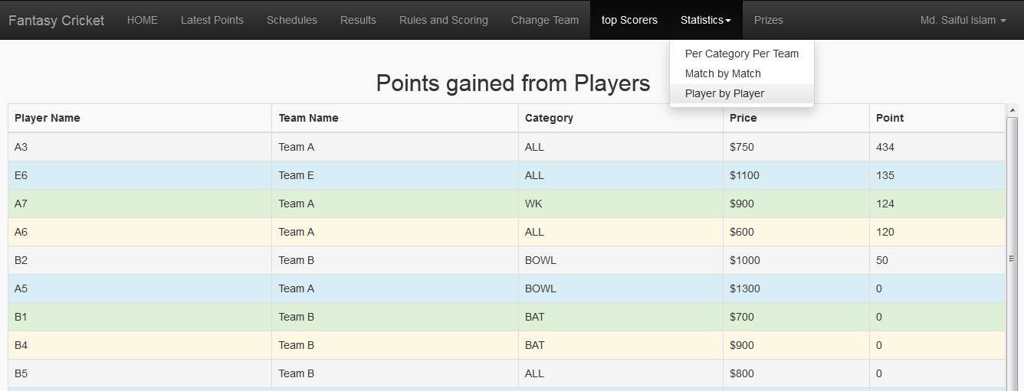

## Change Password

If you want to change the passwords then click: User Name > Change Password. User Name is located in top right corner of the window.

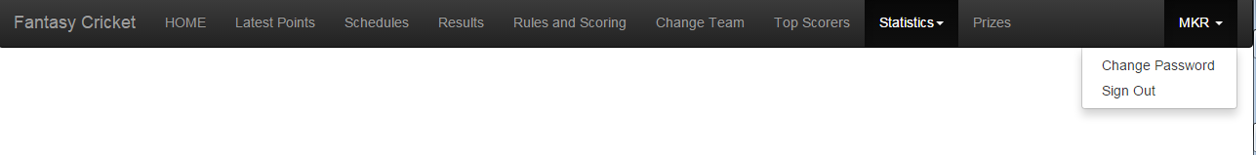

## Sign Out

By clicking User > Sign out link you will exit your profile and session will expire.